TODAY’S TAKEAWAYS
GRAMMAR | VOCABULARY | PRONUNCIATION
- I like teaching. | - midday: meio-dia  - pretend: fingir  - intend: pretender  - coal: carvão  - enough: suficiente  - barrel  - queijo maturado / curado: aged cheese or mature cheese  - forno a lenha: coal-fired oven  - milk candy: doce de leite  - kitchen: cozinha  - stove: fogão  - oven: forno  - molasses: melaço  - grow vegetables: cultivar vegetais  - avocado: abacate  - impressive  - manure: esterco  - compost: composto (compostagem)  - life expentacy: expectativa de vida  - at least: pelo menos  - retirement: aposentadoria  - all day long: o dia todo  - scholarship: bolsa  - self-employed; freelancer: autônomo | - interesting

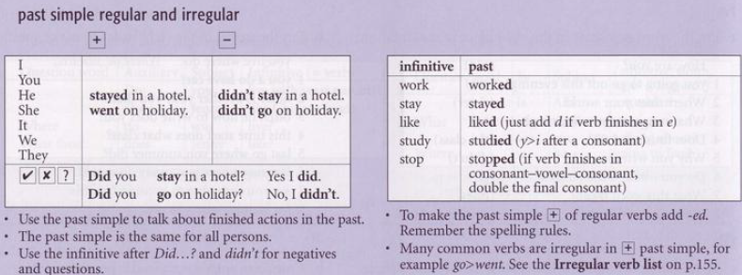

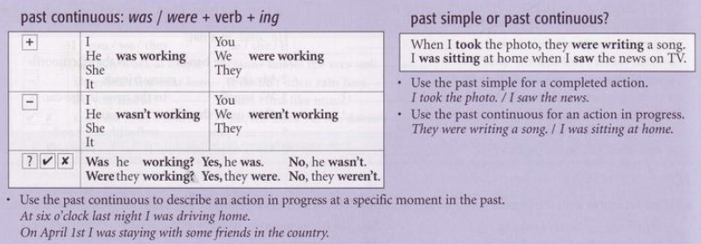

Controlled practice with simple past and past continuous
- The baker / drop / the tray / while / he / take / the fresh bread / out of the oven.
- The baker dropped the tray while he was taking the fresh bread out of the oven.

- The chef / prepare / the signature dish / when / he / burn / his finger.
- It / start / to hail / while / we / hike / through the forest.
- The students / whisper / to each other / when / the teacher / walk / into the classroom.
- Lucas / wait / for the bus / when / he / see / a famous actor.
- My neighbor / begin / to play the drums / while / I / try / to sleep.
- The technician / repair / the server / when / the power / go out.
- Sarah / drive / to the interview / when / she / realize / she / forget / her resume.
- They / discuss / the new project / when / the CEO / interrupt / them.
- The kids / find / an old treasure map / while / they / play / in the garden.
- The athlete / lead / the race / when / he / suddenly / trip / and fall.
- While / we / fly / over the Alps / the pilot / make / an important announcement.
- I / browse / the bookstore / when / I / run into / my primary school teacher.
- The sun / shine / brightly / when / we / arrive / at the beach.
- Something / go / wrong / while / the scientist / conduct / the experiment.
- Everyone / dance / at the party / when / the music / stop / abruptly.

Controlled practice of past simple and past continuous. [ business sentences ]
Example:
- The project manager / enter / the room / while / the developers / debate / the software architecture.
- The project manager entered the room while the developers were debating the software architecture.

- The marketing team / brainstorm / new ideas / when / the fire alarm / ring.
- While / the CEO / deliver / her speech / the microphone / stop / working.
- We / discuss / the budget / when / the client / ask / for a discount.
- The Wi-Fi / disconnect / while / I / give / a virtual presentation.
- The HR manager / review / resumes / when / her computer / crash.
- While / the legal team / draft / the contract / they / find / a major error.
- The delivery / arrive / while / the warehouse staff / take / their lunch break.
- Sarah / prepare / the monthly report / when / she / notice / a missing invoice.
- They / negotiate / the merger / when / the news / leak / to the press.
- The lights / flicker / while / we / hold / the board meeting.
- While / the intern / photocopy / the documents / the machine / jam.
- I / check / my emails / when / I / receive / the promotion offer.
- The customer / hang up / while / the agent / look for / their account details.
- The sales team / celebrate / their success / when / the manager / announce / more work.
- While / the analysts / study / the market trends / the stock price / drop / suddenly.

